**ASHNA.V**

**230701042**

**Ex No: 1a)**

**INSTALLATION AND CONFIGURATION OF LINUX**

**Aim:**

To install and configure Linux operating system in a Virtual Machine.

**Installation/Configuration Steps:**

1. Install the required packages for virtualization dnf install xen virt-manager qemu libvirt
2. Configure xend to start up on boot systemctl enable virt-manager.service
3. Reboot the machine Reboot
4. Create Virtual machine by first running virt-manager virt-manager &
5. Click on File and then click to connect to localhost
6. In the base menu, right click on the localhost(QEMU) to create a new VM 7.

Select Linux ISO image

1. Choose puppy-linux.iso then kernel version
2. Select CPU and RAM limits
3. Create default disk image to 8 GB
4. Click finish for creating the new VM with PuppyLinux

**Output:**

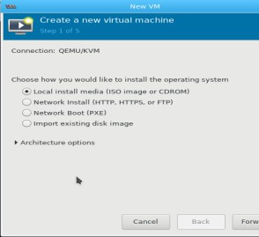

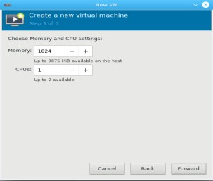

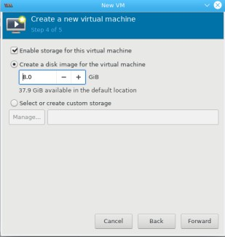

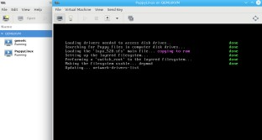

**Ex No: 1b)**

**BASIC LINUX COMMANDS**

**Aim:**

To study and execute basic Unix commands related to date, echo, calendar, users, directories, file handling, filters, and process management.

**Program:**

# Display current date and time

$ date

# Display month only

$ date +%m

# Print a message on the screen

$ echo "God is Great"

# Show calendar for January 2012

$ cal Jan 2012

# Use calculator

$ bc -l

16/4

5/2

# Show who is logged in

$ who

# Show current user

$ who am i

# Show user ID

$ id

# Show terminal name

$ tty

# Clear the terminal

$ clear

# Manual of 'ls' command

$ man ls

# Show current processes

$ ps

$ ps -e

$ ps -aux

# System info

$ uname -a

# Show working directory

$ pwd

# Create directory

$ mkdir receee

# Remove directory

$ rmdir receee

# Change directory

$ cd receee

# List files

$ ls

$ ls -l

$ ls -a

# Create a file

$ cat > rec

(Enter contents and press Ctrl+D)

# Display file contents

$ cat rec

# Copy file

$ cp rec copyfile

# Remove file

$ rm copyfile

# Move file

$ mv rec movedrec

# Find file type

$ file movedrec

# Count lines, words, characters

$ wc movedrec

# Redirect output to file

$ ls > listfile

# Pipe example

$ who | wc -l

# Tee command

$ who | tee userlist | wc -l

# Use metacharacters

$ ls r*

$ ls ?kkk

$ ls [a-m]*

$ ls [!a-m]*

# File permissions

$ ls -l college

# Change permissions using chmod

$ chmod u-wx college

$ chmod u+rw, g+rw college

$ chmod g=wx college

# Change permissions using octal

$ chmod 761 college

# Grouping commands

$ who; date

$ who && date

$ who || date

# Filters

$ head college

$ head -5 college

$ tail college

$ tail -5 college

$ ls -l | more

$ grep "cse" student

$ sort college

$ sort -u college

$ nl college

$ cut -c 1-5 college

# Display memory

$ free -t

**Output:**

$ date

Mon May 27 13:20:15 IST 2025

$ echo "God is Great"

God is Great

$ cal Jan 2012

January 2012

Su Mo Tu We Th Fr Sa

1 2 3 4 5 6 7

8 9 10 11 12 13 14

15 16 17 18 19 20 21

22 23 24 25 26 27 28

29 30 31

$ who

user1 tty1 2025-05-27 08:30

user2 pts/0 2025-05-27 08:45

$ ls

college student movedrec

$ wc movedrec

10 25 132 movedrec

$ chmod 761 college

# Sets permission: -rwxrw--x